**Level 0 DFD for Hospital Management System**

**Noun and Noun Phrases**

1. Hospital Management System
2. Admin
3. Patient
4. Doctor
5. Appointment Database
6. Report Database
7. User Information Database
8. Request
9. Appointment
10. Report
11. Status

**Verb and Verb Phrases**

1. Manage
2. Request
3. Submit
4. Cancel
5. Check

**Level 0 DFD**

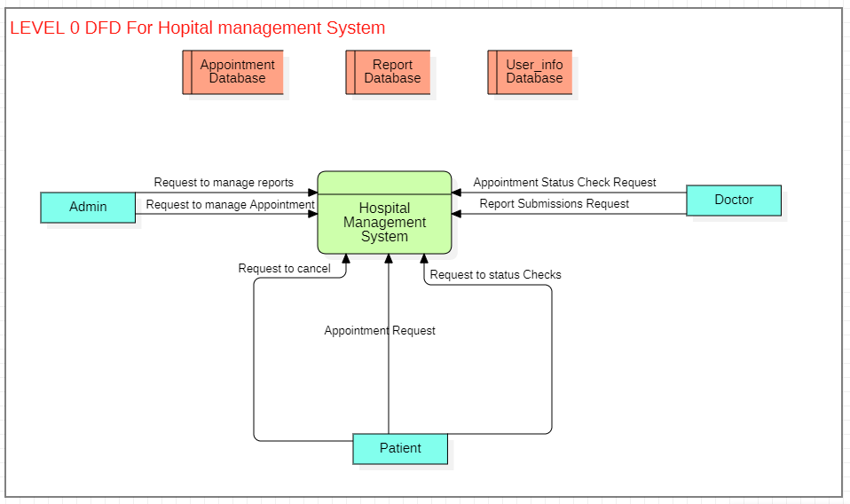

**Level 1 DFD for Hospital Management System**

**Nouns and Noun Phrases**

1. Admin
2. Patient
3. Doctor
4. Manage Appointments
5. List Appointments
6. Add Appointment
7. Update Appointment
8. Cancel Appointment
9. Check Appointment Status
10. Manage Reports
11. Add Report
12. Generate Report
13. Show Report
14. Change Report Status
15. Appointment Database
16. Report Database
17. User Information Database
18. Request
19. Status
20. Data

**Verb and Verb Phrases**

1. Manage (as in "manage appointments")
2. List (as in "list appointments")
3. Add (as in "add appointment" or "add report")
4. Update (as in "update appointment")
5. Cancel (as in "cancel appointment")
6. Check (as in "check appointment status")
7. Generate (as in "generate report")
8. Show (as in "show report")
9. Change (as in "change report status")
10. Store (as in "store new appointment" or "store new report")
11. Retrieve (as in "retrieve appointments" or "retrieve report data")
12. Remove (as in "remove appointment")
13. Request (as in "request to add appointment" or "request to check status")Level 1

**Level 1 DFD**

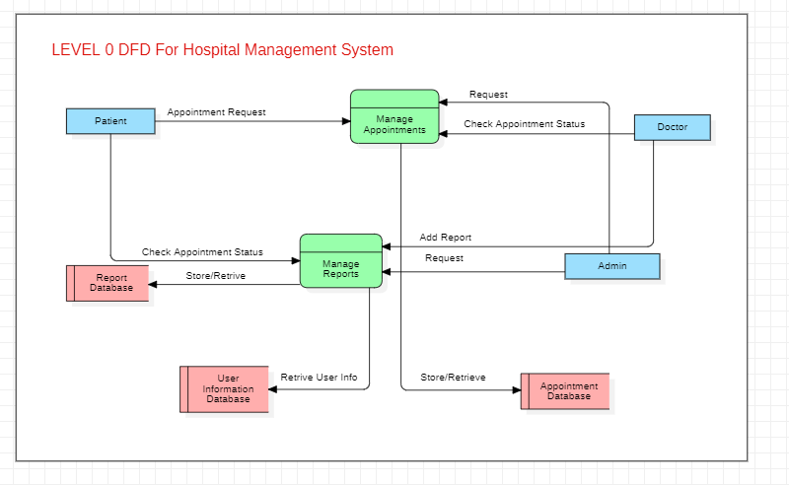

**Level 2 DFD for Hospital Management System**

**Nouns and Noun Phrases**

1. Admin
2. Patient
3. Doctor
4. Manage Appointments
5. List Appointments
6. Add Appointment
7. Update Appointment
8. Cancel Appointment
9. Check Appointment Status
10. Manage Reports
11. Add Report
12. Generate Report
13. Show Report
14. Change Report Status
15. Appointment Database
16. Report Database
17. User Information Database
18. Request
19. Status
20. Data

**Verb and Verb Phrases**

1. Manage
2. List
3. Add
4. Update
5. Cancel
6. Check
7. Generate
8. Show
9. Change
10. Store
11. Retrieve
12. Remove
13. Request

**Level 2 DFD**

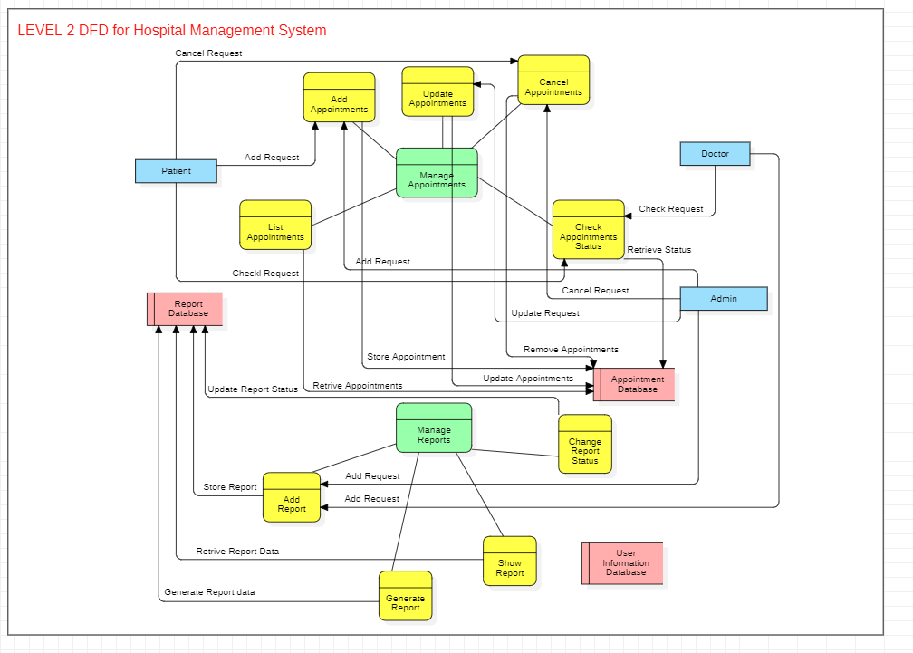

**Level 3 DFD for Hospital Management System**

**Nouns and Noun Phrases**

1. Hospital Management System
2. Manage Appointments
3. Manage Reports
4. Retrieve Appointment List
5. Filter Appointments
6. Validate Appointment Data
7. Store Appointment
8. Retrieve Appointment Details
9. Update Appointment Data
10. Retrieve Appointment for Cancellation
11. Remove Appointment
12. Retrieve Appointment Status
13. Display Appointment Status
14. Validate Report Data
15. Store Report
16. Compile Report Data
17. Generate Report Document
18. Retrieve Report for Viewing
19. Display Report
20. Retrieve Report Status
21. Update Report Status
22. Admin
23. Patient
24. Doctor
25. Appointment Database
26. Report Database
27. User Information Database

**Verbs and Verb Phrases**

1. Manage
2. Retrieve Filter
3. Validate
4. Store
5. Update
6. Remove
7. Display
8. Compile
9. Generate

**Level 3 DFD**

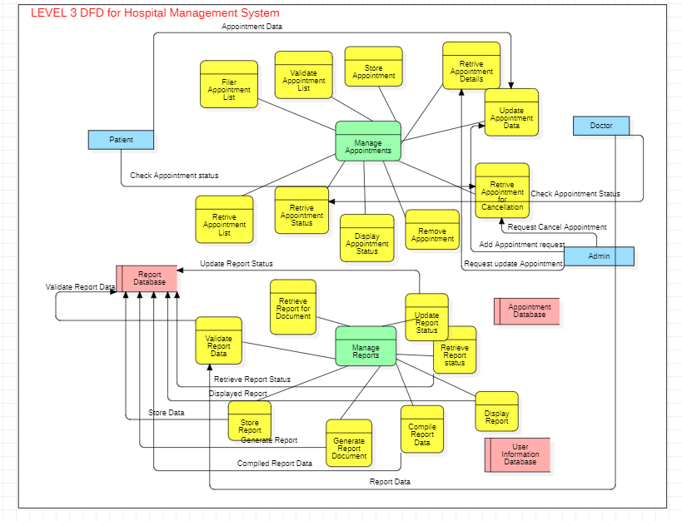

**Level 4 DFD for Hospital Management System**

**Nouns and Noun Phrases**

1. Hospital Management System
2. Manage Appointments
3. Manage Reports
4. Retrieve Appointment List Logic
5. Format Appointment List
6. Filter Appointments
7. Validate Date and Time
8. Validate Patient Information
9. Create New Appointment Record
10. Fetch Appointment Details
11. Update Appointment Record
12. Verify Appointment for Cancellation
13. Delete Appointment Record
14. Fetch Appointment Status
15. Show Appointment Status to User
16. Check Report Data Completeness
17. Validate Report Format
18. Create New Report Record
19. Gather Data for Report
20. Generate Document from Data
21. Fetch Report for Viewing
22. Present Report to User
23. Check Current Report Status
24. Update Report Status in Database
25. Admin
26. Patient
27. Doctor
28. Appointment Database
29. Report Database
30. User Information Database

**Verbs and Verb Phrases**

1. Manage
2. Retrieve
3. Format
4. Filter
5. Validate
6. Create
7. Fetch
8. Update
9. Verify
10. Delete
11. Show
12. Check
13. Gather
14. Generate
15. Present

**Level 4 DFD**

